THE VP1 RED AIR FORCE
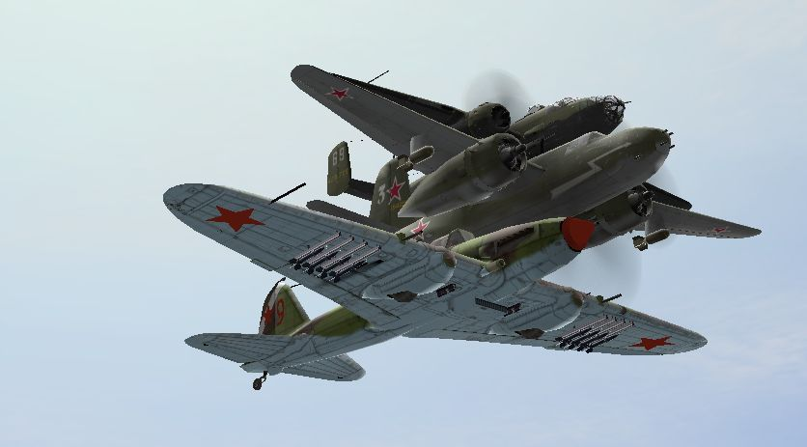

ATTACK AVIATION

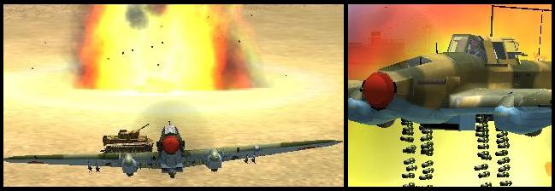

OFFENSIVE WEAPONS MANUAL
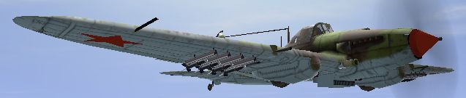
249th_Kernow
References:
A: “Ilyushin IL-2 and IL-10 Shturmovik” by Yefim Gordon & Sergey Komissarov
B: PE Mosor's FB website

I. INTRODUCTION
This work is intended to be a manual on the IL-2’s weapons and how to use them in IL-2 Sturmovik: Forgotten Battles/Pacific Fighters. The information here, as far as I can tell, is correct at the time it was written. However, there may still be some errors; in going over weapon tests I have sometimes found things that were not apparent in the first test. Only my latest data is included here, but even that could be subject to change in later patches. The things most likely to change in any patches are weapon effects; the laws of motion and how they affect aiming ought to remain as they are.
Initially I conducted trials on test ranges in order to improve my accuracy and get greater consistency in my ground attack work, especially with free-fall bombs. Screenshots of weapon impact and weapon release allowed me to work backwards from weapon impact in order to find what point of aim I should use. Later this was backed up with some theory, which proved remarkably consistent with what I had found empirically, so, although I can’t be certain about how the game models reality, I can be fairly sure my theoretical work is very close to the game’s ‘reality.’ Other trials included tests of different weapons on various targets.
The original concept of an IL-2 manual has expanded and now covers the main attack aviation assets available to the Red side in the Virtualpilots server. However, a comprehensive survey of all the ground attack platforms and weapons in the game would be a huge undertaking! Some other time, perhaps.

THE IL-2 STURMOVIK
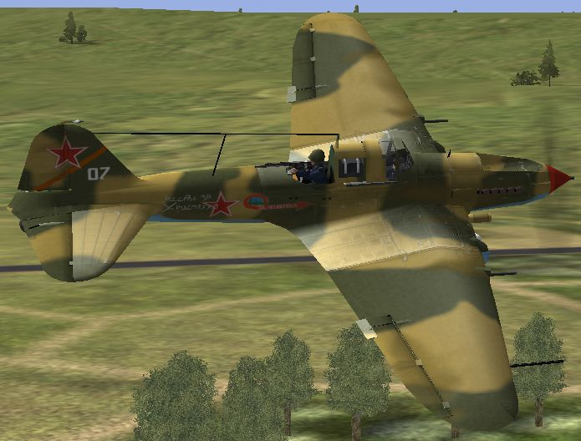

Fig 1
Ilyushin’s IL-2 Sturmovik, seen here in a two-seat version, carries a variety of bombs, rockets and cannon.
There are many sources of information on the IL-2 – not least the game itself – but one I would recommend, and have used as a source in several places herein, is “Ilyushin IL-2 and IL-10 Shturmovik” by Yefim Gordon & Sergey Komissarov (Crowood, 2004, ISBN 1 86126 6251). Although many variants are represented in the game, the principle distinguishing feature for this manual is the gun sight fitted.
Gun sights. See Appendix 1 for an explanation of sights, the use of marks to represent angles, and how the following mil values were derived. The single-seater IL-2 has the PBP-1b gun sight. This could cause injury to the pilot during a forced landing, so the simple VV-1 sight found on the two-seaters in the game replaced it. The VV-1, however, was crude (as we shall see) and didn’t allow for much accuracy in aiming, so later IL-2s had a modified PBP-1b, which could be removed in case of a crash landing. Unfortunately, this is not found in the game where all later IL-2s have the VV-1. These are the two sights:
- PBP-1b. The PBP-1b sight is also found in the Soviet fighters and is shown in fig 2, below. Projecting an image focused at infinity onto a glass screen produces the sight picture. Because it is focussed at infinity the pilot can still see it clearly while looking at a target hundreds of metres away. The sight is symmetrical. The outer ring represents 94 mils, the inner 65 mils and the tick marks are at 9 mil intervals, 9, 18, 27 and 36 mils.
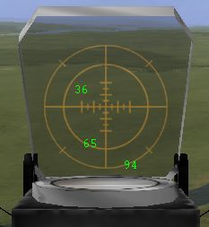

Fig 2
The PBP-1b gun sight fitted to the single-seater IL-2s in the game.
- VV-1. The VV-1 sight is much simpler, being composed of simple markings on the cockpit windscreen, which are aligned with the mast on the nose to provide a simple means of aiming. Note that the rings are not quite centred on the cross hairs, so the angles shown represent the angles at the 6 o’clock position at the bottom of the sight.
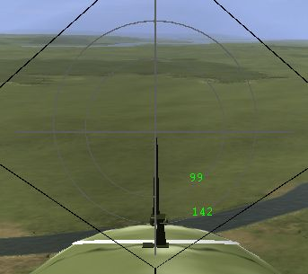

Fig 3
The simple VV-1 gun sight equips the two-seater versions.
The Sturmovik can carry a wide range of munitions up to 250 kg bombs. Although capable of destroying a single medium sized ship with 250 kg bombs, the Sturmovik is better suited to destroying multiple smaller targets, such as tanks, vehicles and parked aircraft with the large number of rockets and relatively small bombs or more specialized weapons it can carry.

THE TWIN-ENGINED BOMBERS
The attack aviation armoury is completed by the A-20G and the B-25J, both of which are twin-engined medium bombers/attack aircraft. Both have simple ring sights for the pilot, which are 43 mils in radius, although the B-25 is also equipped with a bombsight in the nose.
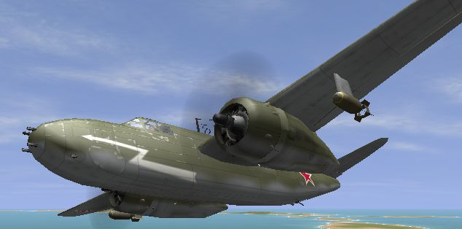

Fig 4
The Douglas A-20G, with solid nose full of .50 cal guns; it carries bombs too.
A-20 Boston. The A-20 can carry various bombs from 40 lb para-frags up to 1000 lb bombs, to a maximum total weight of 2 200 lbs, or a single torpedo. It can carry large numbers of small bombs and has powerful forward firing guns, which allow it to be used against some of the same targets as the IL-2. However, it is the best anti-shipping aircraft as it can carry bombs for two ships or a torpedo, which is the best means of dealing with warships without having to approach too closely.
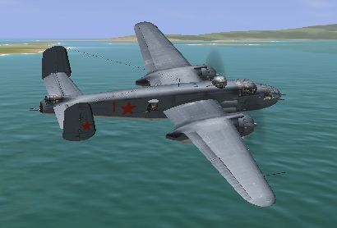

Fig 5
The North American B-25J Mitchell can carry a number of bombs and also has a powerful battery of forward firing guns.
B-25 Mitchell. The B-25 carries the heaviest load, 3000 lbs, and can be used for special attack missions on industrial areas or large troop concentrations. Not really suitable for accurate bombing from the pilot’s position. Also used as a level medium bomber.

II. LEVEL ATTACKS

METHOD
When we release our bomb it will initially continue forward at the speed of the aircraft and start to accelerate downwards under gravity. So long as we are not side slipping, the bomb will land at a point, which, at the moment of release, is straight ahead of the aircraft and lies under the gun sight’s vertical line at some point below the centre. What we need to know in order to accurately aim the bomb is, how far below the centre will the bomb drop?
The two variables are height and speed. The faster we fly the further the bomb will travel and the less it will appear to drop. If we fly higher the bomb will also travel further, but in this case it will appear to drop more. The less the bomb appears to drop the easier it is to aim, so we want to fly as low and as fast as we can for greatest accuracy; any slower/higher than 360 kph and 40 m and the nose will obscure the target at the bomb release point. Equally important is the need to consistently fly the same profile, so that we can always predict where our bombs will go.
Appendix 1 describes how the theoretical numbers in table 1 were derived.
Table 1.
The first three lines show how changes to the speed will alter the required sight angle, with the red figures representing our base starting point parameters. A 30 kph speed change changes the aiming point by just 5 mils – not much on these sights – and that represents about 12 m more or less forward throw. Setting 90% throttle and 90% propeller speed will generally yield 405 kph in a single-seater and 390 kph in a two-seater. These are TAS; with in-game conditions the indicated speed will be slightly less, around 380 kph in a two-seater. Even a 30-kph error will not result in huge errors and we ought to be able to consistently get our speed closer to the desired value than that.
TAS | HEIGHT | SIGHT ANGLE
(kph) | (m) | (mils)
420 | 10 | 60
390 | 10 | 65
360 | 10 | 70
390 | 5 | 46
390 | 7 | 54
390 | 12 | 71
390 | 15 | 79
390 | 3 | 35
The other variable, height, is harder to control, as we don’t have a suitably accurate indication in-cockpit. However, if we fly right on the deck as low as feels reasonably safe, we are probably not far from 10 m. My ultra-low-level height appears to have settled at 7 m, but to start with we’ll assume an attack height of 10 m. See that 2 or 3 m error in height can result in at least as much error as a 30-kph speed change. Strictly speaking, height is not necessarily height above the ground, but height above the point of bomb impact. This might be 1 or 2 m less than aircraft height if the bomb slams into the side of a target. For aiming purposes we’ll assume there is no difference for now.

IRON BOMBS
If we intend to bomb from 10 m at 390 kph we need to allow 65 mils for the bomb drop. Conveniently, this is the inner circle on the PBP-1b gun sight. On the VV-1 it is ²/₃ of the way to the inner ring. If we release bombs at the moment the 65-mil ring reaches the bottom of the target we ought to get the bombs close enough. If we are too low we will end up closer to the target when the 65-mil ring reaches the target, and if we are too high we will be further away. In the first case the bombs will fly into the side of the target; in the second they will drop short, but hopefully still close enough.
Fig 6 shows the point of release where we intend to drop a pair of FAB-100 bombs at the foot of a Tiger tank. We intend to fly at 10 m and 390 kph, so we can use our 65-mil ring as the aiming point. Fig 7 shows we were actually flying at 400 kph IAS or 408 kph TAS at a height of 7 m. If we do the calculations for those parameters we find the bomb drop is 52 mils, which means it will hit the side of the target. That, in turn means it will not drop the full 7 m; however, the bottom line of table 1 shows that the bomb will still fall to the 35-mil point if it drops just 3 m. That is practically the same as the 36-mil ‘tick’ mark, which is almost resting on top of the Tiger’s turret. A bomb-drop of 52 mils or perhaps slightly less (6 m => 48 mils) is mid-way between the 36-mil mark and the 65-mil ring: halfway up the Tiger’s hull where the black cross is.
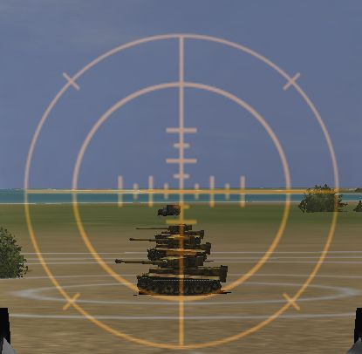

Fig 6 (left)
Aiming to hit the base of a Tiger tank from 10 m at 390 kph.

Fig 7 (below)
This shot shows the actual conditions at the moment of release.
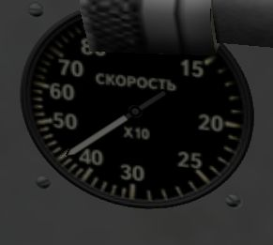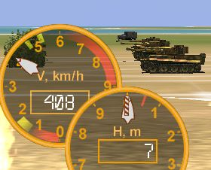
We aimed for the base of the Tiger, but being slightly lower and faster than desired, we can expect the bombs to impact the side of the target. Fig 8 shows the bombs’ impact, which is right on the black cross, as predicted by the post-release recalculation.
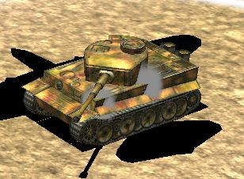

Fig 8
The bombs strike slightly higher than intended, but still hit.
This ought to have the desired effect, and we can see, fig 9, that it does.
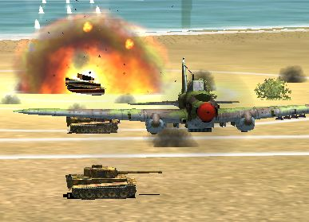

Fig 9
Two FAB-100s will destroy any tank given a direct hit.
Summary. At 390 kph and 10 m the aiming point for a level attack is the intersection of the vertical line and the 65-mil ring. Speed is fairly easy to check and is also easy to maintain with suitable accuracy. With a little training it is possible to be no higher than 10 m during the final stage of the attack. Even if we are much too low and too fast the bombs will still drop to at least the 36-mil tick mark. If we regard the 36-mil and 65-mil points as the possible extremes, then another look at fig 6 shows the target almost completely fills that area of the gun sight in which the bombs must land. Releasing bombs as the 65-mil ring reaches the target should guarantee a hit if we are about as low as we can get and have controlled our speed with some accuracy. The VV-1 sight requires a little more judgement in its use, but can still be almost as accurate.

AREA EFFECT MUNITIONS
The principles outlined above apply equally to bomblets like theAO-10, which drop in long sticks. These weapons can cover a zone up to 300 m long, so are normally used on targets comprising groups of vehicles, guns etc or linear targets such as road convoys. The big problem with level bombing from low-level is judging the range to the target. Because these weapons drop in long sticks they essentially solve all our aiming problems. The main modification to the technique is generally to start dropping bombs some time slightly before the aiming point reaches the target. There is no point in running the risk of missing the start of the target. Most targets are not as long as the beaten zone anyway, so the end of the stick will generally land beyond the target. If we guarantee hitting the leading edge of the target zone we will still have plenty of munitions to cover the remainder of most typical targets. In this respect PTABs, AJ-2 cassettes, AO-10s and VAP-250 can all be treated in the same way.
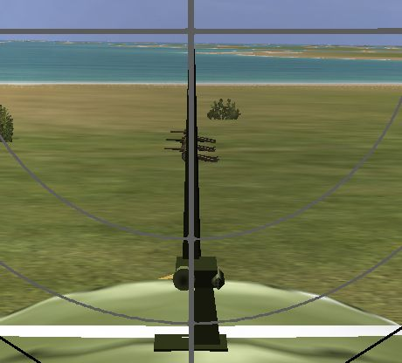

Fig 10
The first howitzer in the target battery is halfway between the inner ring and the centre point, ie 50 mils depressed. Releasing the AJ-2 cassettes now will ensure all guns get covered in the beaten zone.
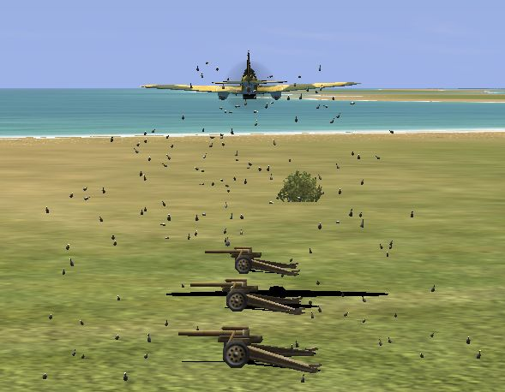

Fig 11
Here we can see the first ampoules landing just short of the target battery, as desired. There will still be plenty for the third gun.

STRAFING
Gun and cannon attacks can also be made from a very low-level approach, although a shallow dive is more usual. A level attack is most suited to individual attacks on specific vehicles, especially if we want to put rounds into the side or rear of a tank. As range tends to be less than in a dive attack, convergence can be set to something like the normal air-to-air value around 200 m.

SKIP BOMBING
Introduction. Mast-head bombing became the favoured method for sinking ships in the IL-2. The actual strike aircraft were usually accompanied by at least as many IL-2s armed with rockets and small bombs, whose job was to suppress the enemy defences. This is not a method for making solo attacks on warships, as flying straight at the target – and any gunners on board – just gives them a very easy shot at close range. Undefended merchant ships are another matter. Skip bombing is really just a variation on the iron bomb case we looked at above, but with 250 kg bombs skipped across the water against ships.
The very low and very close method. The ‘dead certain’ method is to fly as low as possible, ie at or below deck height, and drop the bombs at the last moment before pulling up to avoid the masts and rigging on the target ship. Being so low means the bombs can’t fly over the target and getting close means they will hit the side whether they need to skip on the water or not. The ship must really fill your view at bomb release, but your bombs will hit it.
Skipping bombs. In order to skip, bombs must be dropped from 50 m (150 ft) or lower. Naturally, the initial forward throw will reduce as the height is reduced; however, a lower drop means the bombs don’t hit the water as hard and therefore they skip further. The first two skips cover the greatest distance, after which only a few metres are covered in the final skips before the bomb sinks. After the first impact we can count on the bomb covering something over 100 m. After release the bombs pretty much keep up with the dropping aircraft, but after the first bounce they slow down and the aircraft rapidly gets ahead of the bombs. By the time the bombs hit the target the dropping aircraft could be outside the lethal radius, so a delay is not always essential – but will be useful should the bombs reach the target without skipping.
Increasing height and range. By increasing our height we can get maximum range on the bombs. At 35 m and 365 kph we can expect a theoretical forward throw of 270 m, plus at least another 100 m for the skips, making 370 m. To make sure of a hit we will round that down to 350 m. At a height of 35 m a range of 350 m equates – very conveniently – to a 100 mils depression or the inner ring on the VV-1 gun sight. We will drop our bombs when the inner ring reaches the target’s hull at the waterline. On the PBP-1b 100 mils is somewhere in the small gap just below the outside (94-mil) ring and the solid gun sight mounting.
Example skip bomb attack. With two FAB-250 bombs a two-seater IL-2 at 90% propeller speed and throttle will make around 365 kph. The height is judged at 35 m by keeping just above the top of the ship’s masts and by checking speedbar (and altimeter). Figs 12 & 13 show the situation at the moment the bombs are released.
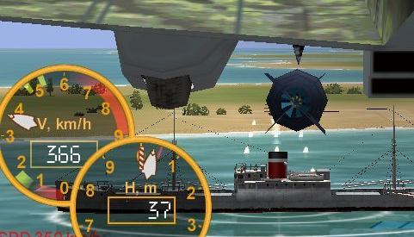

Fig 12
See that this bomb has just been released from the aircraft at 37 m and 366 kph.
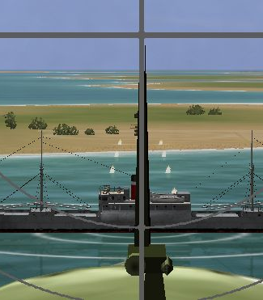

Fig 13
This is a fraction after the button was pressed, which is why the bombs have actually started to fall away in the fig above and is why the inner ring has now passed the waterline. Essentially, however, this is the aiming picture.
At the moment depicted in figs 12 & 13 the IL-2 is about 352 m from the near side of the ship. The bombs travel 270 m to skip at 80 m from the ship’s side. They skip a second time about 70 m later, one either side of the 12.5 m mark, as shown in fig 14.
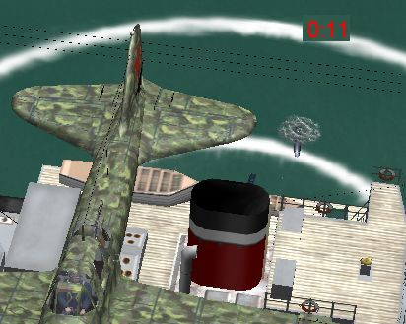

Fig 14
One bomb has just splashed a metre or two outside the 12.5 m ring and the other can just be seen behind the funnel.
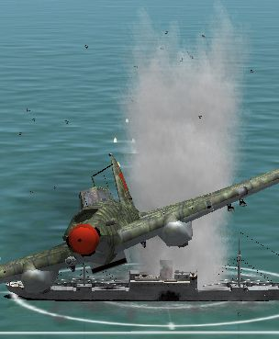

Fig 15
The result is one destroyed merchant ship.
Skip bombing in the A-20 and B-25. Anti-shipping missions, by definition, must mean flying over water - quite a lot of water sometimes. Unless you like getting wet, two engines are better than one when flying over the sea, especially if we are going to attack heavily defended ships. The IL-2 is a reasonable anti-shipping aircraft, but the twins have greater survivability and hitting power. The very low and very close method can be used in either twin-engined bomber, although the B-25 in particular needs more room in which to pull up. The A-20 can employ a higher attack from the pilot’s position; the B-25 needs to use other methods, which are described in the section on the B-25. In an A-20 at 100 ft and 240 mph, bombs dropped when the waterline is about to disappear below the nose will just skip to the target on the second bounce; bombs released when the funnel (cargo ship) disappears below the nose will reach the target without needing to skip. Therefore, bombs need to be dropped as the ship starts to disappear below the nose, but before it is out of sight. There can be a tendency to get lower as the target is approached, probably as there is a natural tendency to fly at the target. If, on the other hand, the aircraft enters a slight climb there is a danger we could release at too great a range, because the release picture – fig 16 - will be reached earlier than intended due to the nose up attitude.
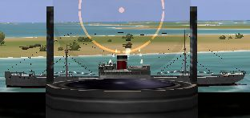

Fig 16
This is the ideal release picture for an A-20 skip bomb attack at 100 ft. The range was just over 300 m and the bomb comfortably reached its target.

III. DIVE ATTACKS

METHOD
In the previous iron bombs example, a level attack with FAB-100 bombs, the bombs were released at a range of 105 m, but the forward throw would have been 135 m. That didn’t matter against the Tiger tank which was our target, as the Tiger’s side obligingly intercepted the bombs, but a less solid target, such as artillery, would not have caught the bombs and they would have gone 30 m long. That is the problem with low-level, level bombing: pinpoint accuracy against a point on the ground is very hard to achieve.
In theory we could get such pinpoint accuracy by diving vertically and putting the target right under the cross hairs. Real Sturmoviks were limited to dives of 30º and the practical in-game limit is probably about the same. Fortunately, even a shallow 10º dive can improve horizontal accuracy.
At first sight the introduction of another variable – the dive angle – might seem to make consistent accuracy harder to achieve. However, increasing the dive angle is one of those things which brings the aiming point up towards the centre of the sight, and that is generally a good thing.
Table 2 shows the required aiming point for attacks made in dive.

Table 2.
In a 10º dive, even with a release at 30 m (three times as high as the level case) the aiming point is 12 mils closer to the center than it was in the level attack. Although errors due to variation in speed are slightly greater than they were in table 1, it should be remembered that is due to the greater height we are bombing from. The errors are still almost negligible at around 2 mils per 10 kph.
TAS | HEIGHT | DIVE ANGLE | SIGHT ANGLE
(kph) | (m) | (degrees) | (mils)
440 | 30 | 10 | 44
400 | 30 | 10 | 51
360 | 30 | 10 | 61
400 | 20 | 10 | 37
400 | 40 | 10 | 64
400 | 50 | 10 | 76
400 | 30 | 5 | 73
400 | 30 | 15 | 38
Height is still probably the biggest cause of error, with a 10 m height error giving around 15 mils of sighting error, and it is the hardest to judge. I’ve gone for a 30 m height as the base height for dropping bombs. This is quite close to the target, which minimizes the errors, and is reasonably easy to judge, being the height at which the target and ground suddenly seem to get much larger, leading to a natural desire to pull up.
The artificial horizon in the cockpit does not give a good indication of what your dive angle is. However, a 10º dive is fairly easy to judge, being a fair bit steeper than an approach to land, but still an essentially shallow dive. We mentioned earlier that the VV-1 is not symmetrical, as the rings are slightly offset. At the 12 o’clock position the outer ring of the VV-1 is not 142 mils from the center, but is 177 mils, or just over 10º, above the center of the gun sight. Diving to put the top of the outer ring on the VV-1 on the horizon means the center of the sight – and the aircraft – is pointing about 10º down.
Dive bombing parameters and sighting. For dive-bombing we will assume a dive angle of 10º, a speed of 400 kph (250 mph) and a release height of 30 m (100 ft). This produces a required sight depression of 50 mils (51 actually). That is mid-way between the 36-mil tick mark and the inner ring on the PBP-1b, mid-way between center spot and inner ring on the VV-1 and just outside the ring on the sight in the A-20. The B-25 does not really have a good enough forward view to allow shallow dive-bombing with any accuracy; the target is out of sight under the nose when the bomb release point is reached.

IRON BOMBS
IL-2 dive-bombing. This example dive-bomb attack was made in a single-seater IL-2. I used the 50-mil point as the aiming mark. The fig 17 shows the gun sight view at the moment of bomb release.
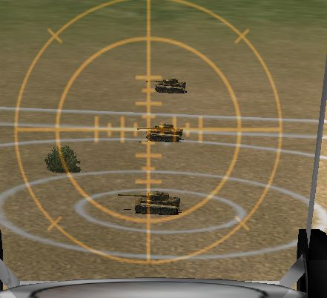

Fig 17
A fraction after the button was pressed, but the 50-mil point is still on the target.
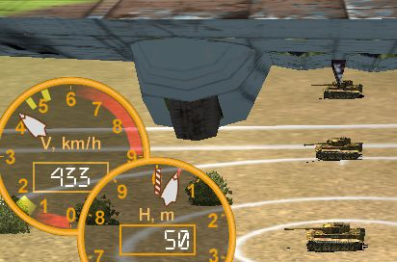

Fig 18
As the bomb doors begin to move we are actually at 50 m, doing 433 kph; dive angle was calculated to be 11º.
From the parameters at weapon release, it looks as if the bombs will drop 64 mils, practically on the gun sight inner ring. From fig 19 it looks like they will land a little short, but close enough. Fig 20 shows that is indeed the case.
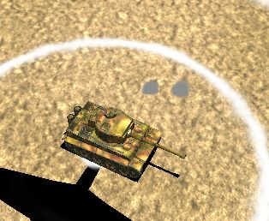

Fig 19
That is probably close to the limit for a result with FAB-100s. The ring is at 12.5 m. Being faster and steeper partly compensated for being higher than desired, but not completely.
This attack ended up with a bomb release quite a bit higher than desired, which resulted in the bombs dropping short, fig 18. To correct that error I need to make sure the Tiger appears almost twice as big in the sight. I could also throttle back a little to keep the speed around the 400-kph mark, which will also give a bit more time to get the aim right. In the IL-2 any throttling back should be done early on during the attack to avoid torque changes throwing the aim off.
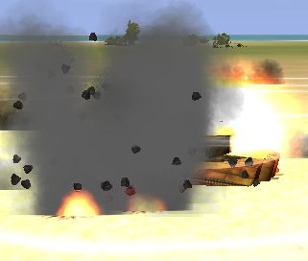

Fig 20
The bombs have just detonated in the foreground, but see how the exploding Tiger has already produced a larger fireball. This can be more dangerous to our aircraft than the bomb explosion.
Dive-bombing in the A-20. The next figs illustrate an attack by an A-20 armed with 500 lb bombs. The target is a Tiger again and the aiming point is mid-way between the ring on the gun sight and the solid part of the sight itself, as shown in fig 21.
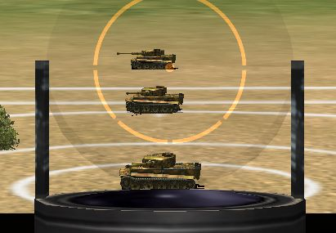

Fig 21
The base of the Tiger’s turret is about 50 mils below the centre spot.
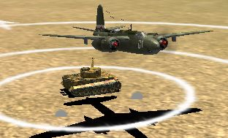

Fig 22
The bombs have dropped roughly as expected, but, coming from the wing pylons, they have passed either side of the target! The next pair, dropping from the bomb bay, would have struck the target.
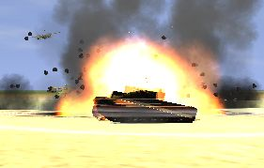

Fig 23
The bombs may have missed, but straddling the target with two 500 lb bombs is good enough.

OTHER MUNITIONS
Area effect weapons. Area effect weapons may also be dropped from a dive attack, although VAP-250 would not be suitable for this method of delivery. A dive attack will generally have the effect of reducing the length of the stick, but will increase the density of coverage. This might be done to increase effectiveness against armour, for example, especially if the target area is smaller than the normal beaten zone.
Rockets. Rockets are best delivered in a shallow dive. Being ‘point and shoot’ weapons they are easy to aim. To allow for a slight drop due to gravity, it is best to put the cross hairs on the top of the target vehicle. A convergence of 500 m works well, so long as you don’t get too close when the rockets could pass either side of the target. If you like to get close use a lower convergence setting. I’ve used 500 m rocket convergence (I think most people use the same) for a very long time, and studying the following rocket attack shows it is a good setting for me. Fig 24 is the view through the sight an instant after the rockets were fired. The target is not the burnt-out tank on the bulls-eye, but the one 50 m beyond.
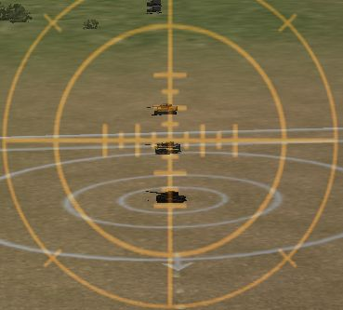

Fig 24
See how the cross hairs are placed at the top of the target to allow for any drop due to gravity. There will not be much drop unless at very long range, but a small allowance, like this, increases the chance of a hit without risking the rockets going over the top of the target.
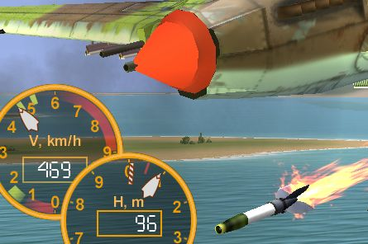

Fig 25
When the shot in fig 23 was taken the rockets had just come off their rails – shown here. Horizontal range from the target was 435 m, therefore, dive angle was 12º and slant range was 445 m.
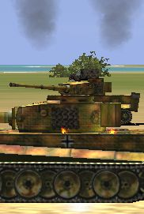

Fig 26
The rockets have almost met at convergence and can just be seen disappearing into the top decking around the turret. In all, the rockets have dropped 3 to 4 mils since launch, or roughly 1 m (3 ft).

STRAFING
Strafing attacks are also usually made from a shallow dive approach. Aim is a simple matter of putting the gun sight on the target, which is static or nearly so compared to an airborne target. Even a long-range shot will not suffer greatly from bullet drop, especially as the bullets are going downhill.
Convergence. In a level attack we can retain the air-to-air convergence setting and approach to close range, but in a dive we need to recover before we hit the ground, so the open fire range tends to be quite a bit greater. We could use any setting up to 500 m. We’ve seen that rocket attacks tend to be around the 500 m range, and guns tend to be used at closer ranges than rockets. To get a good concentration of bullets and shells in the target zone a setting of 300 – 500 m is probably best. I usually use 300 m, as a compromise between air-to-air and air-to-ground use. With the NS-37 cannon a 400 m setting might be better; this cannon is not much use air-to-air, due to the poor rate of fire, and because any hit with it is likely to cripple an enemy fighter there is less need to concentrate the shells at one point – indeed a slight spread to create a ‘shotgun’ effect is probably desirable. Having nose-mounted guns, convergence is clearly not an issue for the A-20 and B-25, which makes them very effective for strafing soft targets at any range.

Direction of attack against convoys and trains. Road convoys and trains make for long, thin targets and it can be tempting to attack them along their long axis. Attacking along the length of a convoy does allow multiple vehicles to be engaged; however, we get lower and lower as we fly the length of the target, due to the diving approach, so hitting the ground can become a hazard. It is normally better to attack from a beam position for several reasons:
- A precise line up on the thin side of the target is not needed in order to be able to attack several vehicles.
- We have a bigger target to aim at as most vehicles and train cars are longer than their width and the whole train or convoy is even larger.
- Multiple vehicles can still be targeted by kicking the rudder left and right once hits are observed on the initial target vehicle, which spreads bullets along the length of the target.
- Attacking along the target’s axis gives any defending flak units an almost zero deflection shot, which helps them; from the beam we are more of a crossing target unless we are attacking the flak vehicle itself.
Direction of attack against tanks. Ideally tanks should be attacked from the rear where the armour is thinner. In addition the attack ought to be made with a steeper dive angle, so that hits can be obtained on the thin top decking over the engine. Speed will build up more quickly, so throttle should be reduced prior to the attack, but time for aiming will still be quite short. Throttling back during the attack is not recommended, because the torque change will throw our aim off, which will more than use up any extra seconds of aiming we gain.
The last paragraph outlined the ideal attack against tanks, which was the recognized best practice, and that is what I generally try to do, as it ought to be the best method. However, in the game I haven’t found a tank that I could destroy with a top rear attack, which I could not also destroy with a straight side or rear shot. Avoiding the front armour is probably the main thing to concentrate on.

IV. THE B-25 BOMBSIGHT AT LOW-LEVEL

THEORY
I don’t know if it has anything to do with how the ‘Norden’ is set up in the B-25, but the theoretical sight depressions don’t work when applied to the bombsight. The numbers for a 220 mph attack at 100 ft indicate a depression of about 7º, which we might expect to be the same as a bombsight angle of 83º. However, that would result in the bomb going too long. The bombsight angle must be measured relative to the vertical, but the gun sight and aircraft longitudinal axis could be a couple of degrees above the horizontal in level flight. That would presumably explain the difference.

PRACTICE
Trials with B-25s dropping bombs on a marked target gave the values found in table 3.
Table 3.
The angles found give the closest result, although the miss distance could be up to 15 m. Clearly not accurate enough for attacking individual tanks or trucks, but good enough for spreading a stick of bombs more widely than is possible with the automated mode, which might be useful when attacking a large industrial area. It is also possible to use the 100-ft figures for skip bombing. Because the bombsight takes time in level flight to properly align itself, it is necessary to get properly lined up at the correct height and speed well in advance: another reason why the target needs to be large.
TAS | HEIGHT | BOMBSIGHT ANGLE
(mph) | (ft) | (degrees)
220 | 100 | 81
220 | 200 | 78
220 | 300 | 76
220 | 400 | 74
220 | 500 | 72

SKIP BOMB ATTACK
In order for the bombs to skip we need to be under 150 ft, so we will use the figures for a 100 ft attack and set the bombsight at 81º.
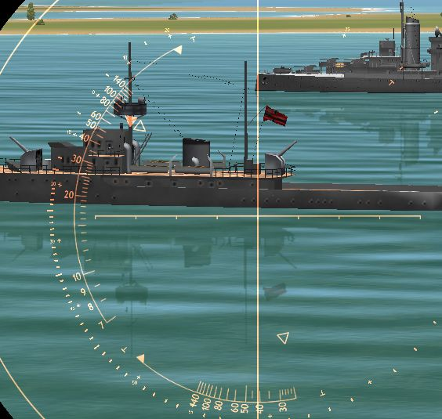

Fig 27
Having confirmed our height and speed, we can engage autopilot and go to the bombsight. With 81º set, the sight shows where the bombs will land. We could have dropped the bombs earlier than this, as they will skip, but this should make sure.
Fig 27 shows the point of bomb release and fig 28 shows the bombs land pretty close to the mark, before skipping into the side of the target.
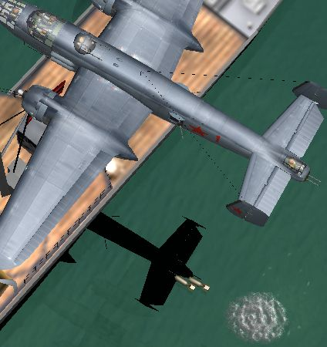

Fig 28
The bombs have landed close to the expected point and have only a few metres to travel before hitting the ship’s hull.
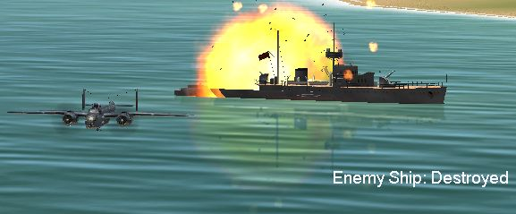

Fig 29
Two 500 lb bombs are enough to destroy an M-boat, but AA fire would normally make this sort of attack extremely hazardous.

V. WEAPONS AND TARGETS

FREE-FALL MUNITIONS
Iron bombs. The FAB series are our basic bombs. They come in three sizes, 50 kg, 100 kg and 250 kg, and are dropped in pairs. They are good general-purpose weapons and work on most targets to a certain extent. Only two FAB-250 bombs can be carried, but up to six FAB-50 or FAB-100 bombs can be carried. On most versions of the IL-2 rockets can also be carried with up to 4 FAB-50 or FAB-100 bombs, but not with FAB-250s. Hard or soft targets can be destroyed by FABs, but the larger ones are obviously more effective. To get an idea of relative effectiveness, here are the results of tests against Tiger tanks:
- FAB-50. Essentially a direct hit is needed to kill a Tiger tank with FAB-50s, although there are a couple of exceptions to that rule: if the bombs strike the turret the Tiger will survive, but a very near miss – within about 1 m – will destroy it.
- FAB-100. A direct hit or a near miss within about 5 m with a pair of FAB-100s will destroy the Tiger.
- FAB-250. A pair of FAB-250s will destroy a Tiger tank if they explode within 10 m of it.
Given that two or three ‘shots’ can be carried with the lighter bombs, this probably makes the FAB-100 the most efficient type of bomb for most purposes. In the game even concrete and steel bridges can be destroyed with light bombs. Where the FAB-250 comes into its own is the anti-shipping role; a pair skipped into the side of a merchant ship or similar size vessel will sink it. The US bombs are similar to their Soviet equivalents and the 1000-pounders available on the B-25 and A-20 are the largest bombs available to ground attack aircraft.
PTAB 2.5 kg bombs. These hollow-charge anti-armour bombs were introduced at Kursk and proved to be effective. They drop straight down in a dense stick that stretches for almost 200 m at 360 kph. Anything flown over will catch several bomblets and any vehicle hit will be destroyed, even heavy armour. They are also effective against soft vehicles. A single load of 96 PTABs can be carried with rockets or a double load of 192 can be carried alone. There seems little in-game advantage to the double load, as they cover the same ground, only with twice as many bombs. As the bomblets do not scatter laterally and as a single load is sufficient to kill even Tigers, the extra bomblets in the double load are wasted. Bomb delay does not affect PTABs, but, as fig 29 shows, they do not detonate on impact. They seem to fall through game objects and I suspect they explode on contact with the ground.
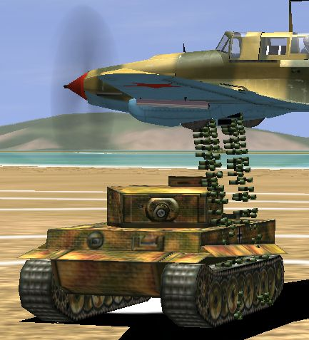

Fig 30
See how the PTABs come down in dense straight sticks with no scatter. Two-dozen of them must have hit this Tiger.
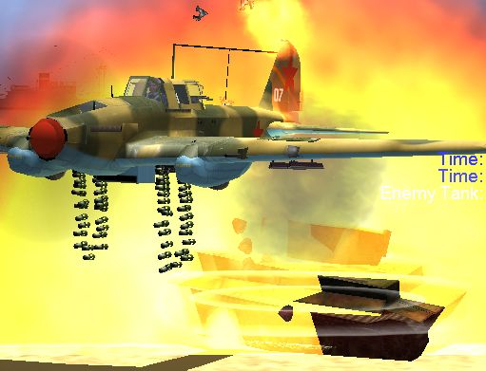

Fig 31
The bomblets explode almost instantly, killing the tank. Strangely, in this case self-damage is never an issue.
AO-10 10 kg bombs. Thirty or fifty AO-10 bombs can be carried in the IL-2’s bomb bays. Rockets may not be carried with AO-10s. These bombs scatter laterally a little, unlike the PTABs, but essentially they will still only affect the area overflown. The smaller load covers about 150 m and the larger one 280 m. Bomb delay does affect AO-10 and setting a nominal half-second or so is probably wise. They are very effective against soft targets, but totally ineffective against tanks.
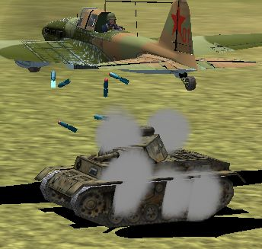

Fig 32
AO-10s tumble and scatter more than PTABs. Five, at least, have hit this Pz.III, but it survived. A single bomb can destroy a truck or artillery piece, however.
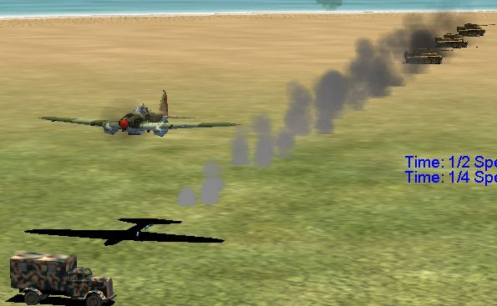

Fig 33
The first bomb in this stick of fifty struck the Tiger, top right; the last couple are about to land on the shadow of the IL-2. The truck is 300 m from the first Tiger and just escapes destruction.
AJ-2 cassettes. This must be the weapon referred to as AZh-2 in Ref A. The cassettes contain ampoules of the KS self-inflammable liquid. These ampoules scatter more than either PTABs or AO-10s and will affect an area either side of aircraft track; the affected zone is about 200 m long. A very effective weapon against soft targets, but also useful against armour, including heavy tanks. Typically about two out of three tanks in the target zone will be destroyed. Fig 11 shows the ampoules scattering about 12 m either side of the centreline. Destructive and with a large footprint, this is a good general-purpose weapon that should guarantee a hit on something.
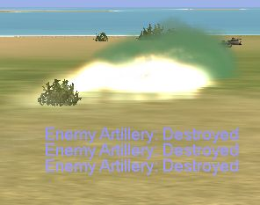

Fig 34
All three howitzers targeted in fig 11 are destroyed.
VAP-250. I believe this to be what Ref A calls the AOG flame-thrower, which consisted of the UKhAP-250 universal chemical container with inbuilt ignition. This was tested, but never used in combat, as the flame intensity at ground level was insufficient, even after a drop from just 10 m. However, in game it is very effective up to 20 m or so. Small chemical containers ignite shortly after leaving the aircraft and cover a zone up to 320 m long and perhaps 20 m wide. Very similar to AJ-2 in effect, but after dropping VAP-250 there is still the weight and drag of the containers on the wings.
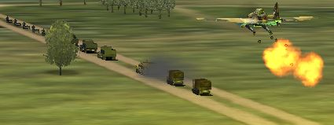

Fig 35
A convoy on the move: an ideal target for VAP-250, seen here at the moment of ignition.
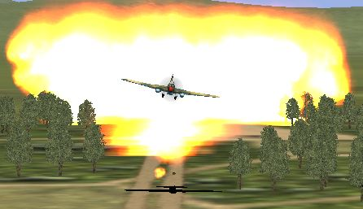

Fig 36
The target is engulfed and exploding vehicles increase the area of effect.
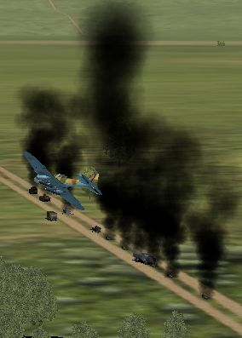

Fig 37
A couple of trucks escaped, but nine other vehicles, including an armoured half-track, were destroyed. All accomplished in one strike with no need to make multiple bomb and rocket passes.
40 lb para-frags. Forty-pound parachute-retarded bombs are available to the B-25 and A-20. These have some forward throw, but then the parachute deploys and they drop straight down. The stick is quite widely spaced and extends for some 650 m. The bombs are quite effective against soft targets. Ideally dropped from as low as possible to reduce drifting in any wind, they are best aimed from the nose position in the B-25 and released just before over flying the target area. Being retarded and relatively small there is no danger of self-damage.
Self-damage. Dropping bombs at very low level can be dangerous, as we may be very close to the bomb when it explodes. A delay of at least 0.5 s (at 405 kph TAS) is needed with FAB-100 and 0.6 s (at 395 kph TAS) with FAB-250 bombs. Anything less will result in fatal self-damage. That implies a lethal radius of 45 m with FAB-100 and 55 m with FAB-250. To allow for extra damage from the exploding target 1.0 - 1.5 s is a prudent delay. The US 1000 lb bombs can cause damage with a 1.0 s delay, but 1.5 s is safe. The extra damage from the exploding target can be fatal with AJ-2 cassettes and VAP-250 when dropped from 10 m and lower; dropping from slightly higher, 15 – 20 m, is safe. There seems to be no danger associated with PTABs; possibly they have a slight in-built delay, which allows the dropping aircraft to just clear the exploding target, unlike VAP-250 and AJ-2, which have an instant effect.
Dropping bombs as a defence. With the right delay on the right bomb a fighter attacking from the rear at very low level can be destroyed by the blast from a bomb. At maximum speed an IL-2 is doing over 100 m/s. When the dropped bomb lands the IL-2 will be directly over it; 1.5 s later the IL-2 will be 170 m away. Any fighter between 125 and 215 m behind the IL-2 will be in the lethal radius of an FAB-100 with a 1.5 s delay. If the bomb actually hits something the lethal radius will possibly be larger.

ROCKETS
High explosive and fragmentation rockets. The RS high explosive (HE) rockets and ROFS HE/fragmentation rockets are our general-purpose rockets for use against soft targets. The larger, 132 mm, versions are much more effective than the 82 mm RS-82. None of these will destroy heavy armour, like the Tiger tank, even with a direct hit, but the 132 mm rockets will destroy Pz.IIIs and similar with a direct hit. The RS-82 can destroy light armour such as half-tracks and armoured cars. There seems little difference between the RS-132 and the ROFS-132 when it comes to effectiveness against massed soft targets; both can destroy trucks up to about 25 m from the impact point, although not every time. Against light armour the fragmentation effect of the ROFS means it can be effective with a near miss, which is exactly why the Soviets developed it. An armoured half-track survives near misses (~5 m) from the RS-132, but is destroyed when near missed by ROFS-132.
Anti-armour rockets. I believe the M-13 was actually an improved RS-132 introduced in 1942. The game graphic effects seem to indicate an incendiary weapon, but the actual effect is that of an armour-piercing weapon just like the BRS-82 and BRS-132. These rockets have very little blast effect and need to hit their target to destroy it, so near misses are worthless. That makes the HE rockets described above more generally useful. However, all of these armour-piercing rockets will destroy heavy armour, like the Tiger tank, if they hit it. That is true even with the lighter BRS-82 against the Tiger’s frontal armour. These rockets used to work against ships, but that is no longer the case. British 60 lb semi-armour-piercing rockets do work on ships and I assume/think US 5.5” rockets also work, but the Soviet rockets are ineffective against ships now (v4.01).
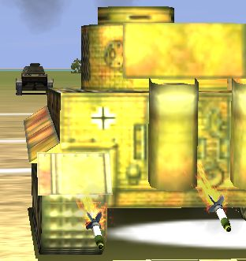

Fig 38
These BRS-82 rockets have just passed through this Tiger, which will be destroyed in a fraction of a second. The rockets struck the top armour at the front.
Summary. Unless the target is known to include heavy armoured vehicles there is no need to take the anti-armour rockets; the RS-132 is effective against most ground targets up to medium tanks. There may be no need to take anything heavier than the BRS-82, as they are capable of destroying even Tigers, just like the BRS-132, and either rocket needs a direct hit. The following, taken from Ref A, shows how the rockets were viewed by those who had to use them for real, “Pilots did not consider the RS-82 projectiles to be a very effective weapon and expressed their preference for the heavier 132mm rockets; they were particularly impressed by the armour-piercing RBS-132 and high-explosive/fragmentation ROFS-132 projectiles introduced in the course of the war (from the spring of 42 the RBS-82 and RBS-132 came into service, supplemented by the V-8 and M-13 projectiles later that year; the last-mentioned 2 types being improved versions of the RS-82 and RS-132 respectively).”
Note on frontal armour. It’s possible that the frontal armour of tanks and self-propelled guns can keep out some rockets that would otherwise destroy them, eg RS-132 against StuG.III (?). I’m not yet totally certain, but even if it is so, it is actually harder to hit the frontal armour than it is to miss it and hit some other part. If in doubt go for a side shot, which presents a larger target anyway, or use armour-piercing rockets, which go through anything, as shown by figs 39 & 40.
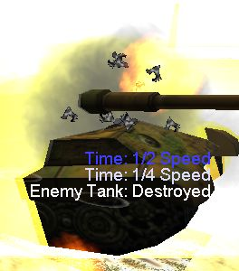

Fig 39
A BRS-82 has just hit this King Tiger on the front of the turret. At 180 mm thickness, it is the thickest armour on this – or pretty much any – tank. A single BRS-82 was enough to destroy this tank.
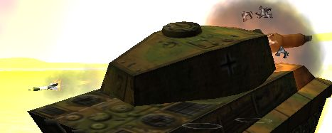

Fig 40
The same moment from another angle. The second rocket can be seen clearly; only one hit is needed.

TORPEDOES
There are two types of torpedo in the game: the original, which has been in the game from the start and which is carried by the IL-2T and He-111; and the new one which came with Pacific Fighters and can arm the Betty, Beaufighter and A-20G. Incidentally, according to Ref A many Russian aviation experts doubt that the IL-2T ever existed; there is no documentary evidence for it and no account of it ever seeing action. However, it is in the game and is sometimes an option that is available.
The original torpedo, Type 45-12. The game’s original torpedo runs at 80 kph for 4 m 30 s (6 km range). Ten are needed to sink a capital ship, assuming they all strike the same area.
The PF torpedo, Mk 13. The newer torpedo runs at 62 kph for 5 m 33 s (5.7 km range). Only six are needed to sink a capital ship.
Using torpedoes. The use of these torpedoes is fairly straightforward, so will be covered here rather than in a separate torpedo-aiming section. The main parameter to observe is the maximum dropping height of 130 m (420 ft). Speed does not seem to matter. It is also important to be level, as any descent will result in the torpedo failing. If we are close enough to see and line up on the target we are probably close enough to drop the torpedo; when any gunners on the target start to shoot we are certainly close enough. Moving targets are another matter entirely, but are not found in DF servers.

GUNS AND CANNON
Ref B is a useful source of information on the weapons used in the game and some of the following weapon information was found there.
Light machine guns. All IL-2s have two 7.62 mm ShKAS machine guns in the wings with 25 s worth of ammunition. They can be used as an aid to sighting rockets and will add to the damage caused by the cannon, either air-to-air or air-to-ground, but are of little use on their own.
Heavy machine guns. The A-20G has six, and the B-25J five, fixed forward-firing .50 cal machine guns in or either side of the nose, with 30 s and 34 s of ammunition respectively. These are very effective against aircraft or soft targets on the ground, such as trucks or AA guns.
ShVAK and VYa cannon. It was planned to arm the Sturmovik with the 23 mm VYa cannon, but problems with the supply of this weapon led to the 20 mm ShVAK being more common initially. Although these problems were overcome and VYa armed versions became common, the ShVAK continued to be fitted to single-seater and two-seater IL-2s throughout the war. In game the early single-seaters have the ShVAK and all later IL-2s are armed with VYa cannon. The ShVAK carried 37 s of ammunition and the VYa 30 s. Although the ShVAK has the higher rate of fire, the VYa is much more powerful. Either weapon can destroy light armoured vehicles, but against tanks both prove to be ineffective.
37 mm NS cannon. To tackle the heavier German tanks various 37 mm cannon were tried on the IL-2. A few single-seaters were fitted with 37 mm cannon and the NS 37 mm was fitted to some two-seaters in time for Kursk. As the guns did not fire simultaneously, only the first rounds could be aimed; the uneven recoil caused the aircraft to yaw and subsequent rounds went wide. This, and the reduced bomb load compared to other two-seaters (no reduced bomb load in game), is the main reason they were withdrawn from service towards the end of 1943, although the guns could penetrate the top armour of Tiger tanks. In the game aiming is pretty straightforward, with no adverse yawing characteristics, however, even hits on the top rear armour of Tiger tanks do not kill them. Lighter tanks are another matter, however, and they can be killed fairly easily with a hit or two. A 12-s supply of ammunition is carried.

CREDITS
Skins by the following appear in screenshots used for this manual:
Monguse (TX)
Serval (1 JaVA)
Rafael
Snake (ex-249th IAP)
Work by other skinners also appears, but I’ve been unable to determine exactly who, and the sites the skins came from are all defunct.
Images were edited with IrfanView.
Thanks to Tooz (69th GIAP) for information on ROFS/RS-132.
249th_Kernow
Sep 2005

APPENDIX 1: THEORY AND FACT FINDING

SIGHTS
Fig 1.1 shows a simple sight, with the viewpoint being at A. The line AB, through the centre of the sight, represents the aircraft axis and is used in the aiming of direct fire weapons like guns and rockets. The line AC, through the ring, represents looking below the aircraft axis by an amount equal to angle a. Clearly the distance, BC, this represents depends on range from the aircraft. The marks around the cross hairs on a sight represent angles that can be used in the aiming of various weapons.
Fig 1.1.
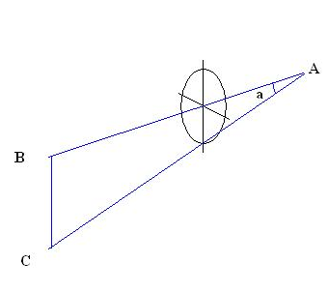
By flying towards a target of known size (merchant ship, 100 m long) along a course with markers to represent distance from the target and pausing when the target exactly filled the sight, it was possible to find out what angles the rings on the sights represent (50 m = Range x tan (sight angle)). Although degrees are used to measure aircraft pitch, it is more usual – and results in more convenient whole numbers – to use mils (milliradians) when talking about angles in gun sights. A complete circle, 360º, is 2π radians, therefore 1º = 0.0175 radians = 17.5 mils.

LEVEL-BOMBING
For the simple level-bombing case we know the speed and height; what we want to find is the forward throw and equate this to an angle in the gun sight, which we can use to aim the bombs. Fig 1.2 shows the geometry of the level-bombing situation.
Fig 1.2.
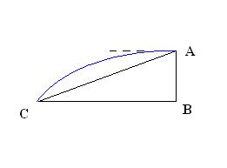

Equations of motion
v = velocity, u = initial velocity, a = acceleration, s = distance, t = time.
s = ut + ½at²
v = u = s/t (unaccelerated)
The aircraft is heading from right to left at speed, v, when it releases a bomb at A. Initially the bomb continues to move with the aircraft, but starts to drop as gravity accelerates it downwards. The bomb follows a parabolic path, represented by the blue line. AB is the height, h, of the aircraft and BC is the forward throw, R, of the bomb. If the bomb takes time, t, to reach the ground, g is the acceleration due to gravity and we ignore air resistance for the moment, then the equations of motion give us the following:
AB = h = ½gt² -- eq 1
BC = R = vt -- eq 2
We know the height, h, speed, v, and g is a constant 9.81 m/s², so we can find t from eq 1 and substitute for t in eq 2 to find the forward throw, R:
R = v√(2h/g) -- eq 3
The angle between the horizontal – the dotted line in fig – and the point of impact at C is, of course, the angle, a, from fig 1.1 above. This is what we want to know when we come to aim the bomb and is the same angle as ∠ ACB in fig 2. As we now know 2 sides of the triangle, AB and BC, we can find the angle:
Tan ∠ ACB = AB/BC = h/[v√(2h/g)] -- eq 4

DIVE-BOMBING
In the previous example we used the height to find the time the bomb is in the air (equation 1) and then used equation 2 to find the forward throw of the bomb. From these two pieces of information we could deduce the angle corresponding to the amount the bomb drops from the horizontal. We can do exactly the same when the bomb is released from a dive at an angle, δ degrees. The situation is slightly more complex, however, because the bomb now has an initial downwards velocity (v.sin δ) and the horizontal velocity (v.cos δ) is not quite the same as the airspeed. The equations for AB and BC now become:
AB = h = vt.sin δ + ½gt² -- eq 5
BC = R = vt.cos δ -- eq 6
Equation 5 results in a quadratic equation, which can be solved to find t. Equation 6 can then give the forward throw, R, which allows us to find AB/BC and then the sight angle. This would be quite tedious to solve for each combination of dive angle, airspeed and release height, but it is not too difficult to produce a spreadsheet, which will do the sums for us once we enter the desired parameters.
The dive angle, δ, is found by noting height, h, and range, D, to the point on the ground under the cross hairs at the moment of bomb release.
Tan δ = h/D -- eq 7
Air resistance. We have not yet considered the effect of air resistance on the falling bomb. Once the bomb leaves the aircraft it will start to slow down. However, so long as the bomb does not produce any lift (either up or down), the drag will only act back along the bomb’s direction of travel. The bomb will slow down and take longer to reach the end point, C in the above fig, but it will follow the same path and still reach that point. At least, that is what I have assumed and results indicate any errors are small enough to ignore once the bomb goes bang.

APPENDIX 2: QUICK REFERENCE PAGE
Table 2.1.
AIRCRAFT | TAS | HEIGHT | ATTACK PROFILE | SIGHT ANGLE
 |  |  |  | mils | PBP-1b | VV-1
IL-2 | 390 kph | 10 m | Level | 65 | Inner ring | ²/₃ Inner ring radius
IL-2 | 400 kph | 30 m | 10° dive | 50 | Mid outer tick/inner ring | ¹/₂ Inner ring radius
IL-2 | 365 kph | 35 m | 100 m skip | 100 | Mid outer ring/base of sight | Inner ring
 |  |  |  |  | US ring sight | ‘Norden’ (degrees)
A-20 | 240 mph | 100 ft | 10° dive | 50 | Mid ring/base of sight
A-20 | 240 mph | 100 ft | 100 m skip | 90 | Just under base of sight
B-25 | 220 mph | 100 ft | Level |  |  | 81
B-25 | 220 mph | 200 ft | Level |  |  | 78
B-25 | 220 mph | 300 ft | Level |  |  | 76
B-25 | 220 mph | 400 ft | Level |  |  | 74
B-25 | 220 mph | 500 ft | Level |  |  | 72

Setting 90% prop & 90% throttle should give close to the desired speed with most loads. In the game IAS is slightly less than TAS at sea level.
Some Soviet fighters were produced in ground attack versions capable of carrying bomb loads. They could use similar settings adjusted slightly towards the centre to allow for their higher speeds.

Table 2.2.
WEAPON |  | TARGET
 |  | Soft | Armour | Area | Ships | Bunkers
ROCKETS | RS-82 |  |  |  |  | Weapons were tested against bunkers and concrete emplacements. However, bunkers seem to give no additional protection in game. Treat bunkers as soft targets or as whatever they contain.
ROCKETS | RS-132, ROFS-132 |  |  |  | 
ROCKETS | BRS-82, BRS-132, M-13 |  |  |  | 
IRON BOMBS¹ | FAB-50, 100 lb |  |  |  | 
IRON BOMBS¹ | 1000 lb |  |  |  | 
AREA EFFECT WEAPONS | AO-10 (x30/50) |  |  |  10x150/280 m | 
AREA EFFECT WEAPONS | AJ-2 |  |  |  25x200 m | 
AREA EFFECT WEAPONS | VAP-250 |  |  |  20x320 m | 
AREA EFFECT WEAPONS | PTAB (x96/192) |  |  |  4x180 m | 
AREA EFFECT WEAPONS | 40 lb para-frags |  |  |  10x650 m | 
TORPEDOES | Type 45-12 |  |  |  | 
TORPEDOES | Mk 13 |  |  |  | 
1. Lightest and heaviest bombs listed. Intermediate bombs have proportionately intermediate effects.
 = Ineffective.
= Slightly effective or needing great accuracy.
 = Effective.
 = Very effective.

